NAME: ATUL SINGH ROLLNO:1900290149029

SEQUENCE DIAGRAM.

EXERCISE: 2

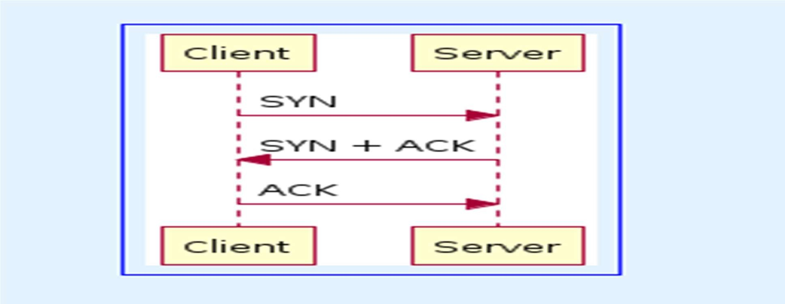

EXERCISE:3

